CHAPTER 1

OVERVIEW

* 1. **Introduction**

Conjugated polymers (CPs) are a class of organic semiconducting materials that have been widely studied over the past few decades, owing to their use as active materials for low-cost photovoltaic (PV) and light-emitting diode (LED) technologies.[PV ref, LED ref, ref McNeill, Monkman, Barbara] These materials exhibit bright emission in the UV and visible spectrum (fluorescence quantum yields ranging from ~30% to nearly 70%), as well as efficient energy and charge transport.[refs]. To improve upon existing technologies, it is necessary to further understand the disordered, heterogeneous photophysics and energy transport phenomena observed in CP thin films and devices. Specifically, it is beneficial to understand how intrinsic defects and polymer structure and conformation affect these processes. Conjugated polymer nanoparticles (CPNs) exhibit similar photophysics to those of CP thin films, but offer greater control over polymer structure compared to thin films via particle size control. By extension, this provides a more reliable means of controlling nanoscale interactions that lead to heterogeneous dynamics in CPs.

CPNs are also ideal for use in fluorescence imaging applications for a variety of reasons. They possess small (4-30 nm) particle diameters, and are easily functionalized and encapsulated.[ref] The photostability figures of merit for CPNs such as ~109 photons emitted prior to irreversible photobleaching and photobleaching quantum yields of ~10-9 are several orders of magnitude better than conventional small molecule dyes and current fluorescent probes. CPNs also exhibit exceptional absorption and fluorescence characteristics, including extinction coefficients of ~109 M-1 cm-1, absorption cross sections of ~ cm2, and radiative rates of ~108 photons/s.[refs] Improvements in nanoparticle fluorescence quantum yield and red-shifting of emission are required for effective use in complex biological samples to ensure sufficient signal-to-noise ratios and to overcome background fluorescence inherent in biological media.

The chapters within this dissertation principally focus on steady-state and time-resolved fluorescence spectroscopy of conjugated polymer nanoparticles with the goal of quantifying the average number of defects in a CPN, along with the length and time scales of exciton motion in CPNs for optimization of device applications. In addition, we aim to improve fluorescence characteristics for imaging applications. Chapter 2 describes the materials, experimental methods, spectroscopic techniques, and instruments utilized in this research. Chapter 3 details the use of dye doping and polymer blending in CPNs with the aim of improving fluorescence brightness and red-shifting emission for fluorescence imaging applications, as well as to quantify intrinsic energy diffusion parameters in CPNs. Chapter 4 delineates the use of solvent-induced swelling coupled with time-resolved fluorescence anisotropy decay measurements to determine the rate of energy transport in undoped CPNs compared to the linear polymer. Both projects utilize a combination of steady-state and time-resolved spectroscopy in conjunction with Monte Carlo simulation to address these issues from multiple angles.

* 1. **Frenkel Excitons and Decay Processes in Conjugated Polymers**

Conjugated polymers possess unique energetic characteristics due to the extended -conjugation (alternating single and double bonds) along the polymer backbone. Upon absorption of a photon, an electron transitions from the  to * electronic band, generating a neutral excitation that is delocalized along a segment of the polymer with unbroken conjugation. This conjugated segment is referred to as a chromophore, which is typically comprised of 2-8 polymer repeat units. The excitation and its polarization field that distorts the local polymer environment comprise the singlet molecular or Frenkel exciton in conjugated polymers. There are various competing rate processes in CPNs that determine the fate of a given exciton after photon absorption (c.f Fig 1.X).

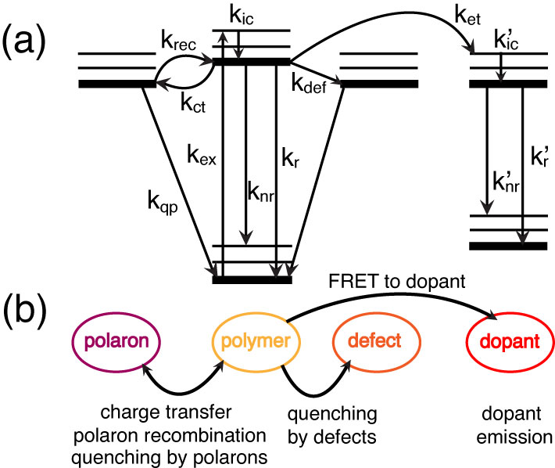

Fig. 1.X. (a) Jablonski diagram illustrating the competing rate processes in doped CPNs. (b) Illustration relating the rate processes in (a) to their respective physical observables.

After internal conversion to the ground vibrational state of the excited electronic state (kic), an exciton may either decay radiatively (kr) or non-radiatively (knr). The exciton may undergo Förster resonance energy transfer (FRET) to a defect site (kdef, discussed in detail later) where the exciton is quenched. Excitons may undergo charge transfer to form hole polarons (kct, discussed later) whereupon the exciton is either quenched (kqp) or the hole and electron recombine to reform the neutral exciton (krec). If a dopant species is introduced into the system, an exciton may undergo FRET to the dopant (ket, discussed below), where similar processes apply if the dopant is a conjugated polymer, or radiative and non-radiative decay may occur if a fluorescent dye dopant is used.

* 1. **Förster Resonance Energy Transfer (FRET) and Exciton Transport in CPNs**

FRET is a process where electronic energy moves between two different molecular species via a resonance process. The molecule that initially absorbs incident radiation resulting in the promotion of an electron to an excited electronic state is referred to as the donor. The molecule that receives the energy from the donor via resonance is referred to as the acceptor. The resonance process of FRET is differentiated from Dexter transfer in that FRET involves energy transfer from the donor to the acceptor, resulting in non-radiative relaxation of the donor electron from the excited state back to the ground state, and concomitant HOMO🡪LUMO excitation in the acceptor. Unlike FRET, the process of Dexter transfer involves electron exchange, where an excited state electron in the donor LUMO moves to the acceptor LUMO and a HOMO electron of the same spin orientation from the acceptor replaces the electron vacancy in the donor. Both processes can facilitate exciton transport in conjugated polymers, but it is hypothesized that FRET is the dominant process. The FRET process is dependent upon several variables, including intermolecular distance, spectral overlap of the donor fluorescence spectrum with the acceptor absorption spectrum, and relative alignment of transition dipole moments between the donor and acceptor. It is convenient to define a distance *R*0 known as the Förster radius, where FRET between the donor and acceptor is 50% efficient. This is given by the equation

, (1.X)

where *n* is the refractive index of the solvent, *N* is Avogadro’s number, *D* is the fluorescence quantum yield of the donor (a measure of the percentage of photon absorption events that result in fluorescence photons). **2 is the transition dipole orientation factor (typically assumed to be 2/3 for isotropic transition dipole orientations), given by

, (1.X)

where the angle a corresponds to the angle between the donor and acceptor transition dipole vectors, b corresponds to the angle between the donor transition dipole vector and the intermolecular axis, and g corresponds to the angle between the acceptor transition dipole vector and the intermolecular axis (c.f. Fig 1.X).

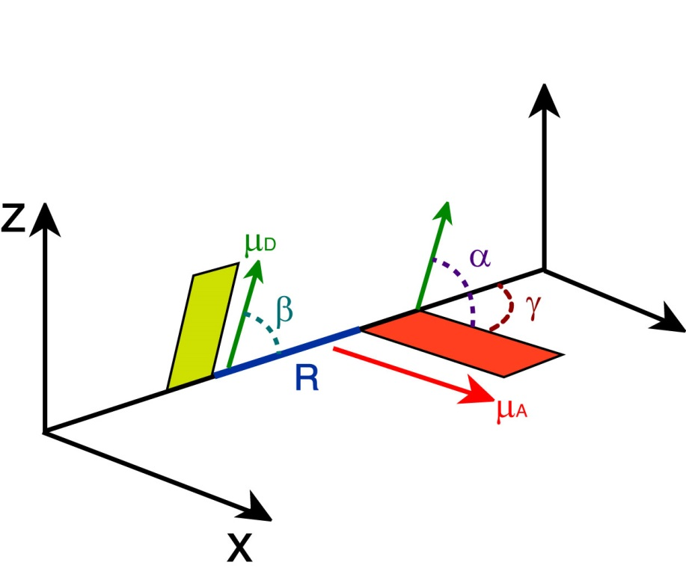

Fig 1.X. Illustration of transition dipole vectors and angles used to calculate **2 for a donor and acceptor pair. D (green) and A (red) correspond to the donor and acceptor transition dipole vectors, R (blue) is the intermolecular distance along the intermolecular axis.

Lastly, *J*(**) is the spectral overlap integral, calculated by

, (1.X)

where ** and *d* are the wavelength and wavelength spacing, respectively, *FD*(**) is the normalized emission spectrum of the donor, and *A*(**) is the extinction spectrum of the acceptor (converted from the absorption spectrum using Beer’s Law). The energy transfer rate constant (*ket*) is determined using the Förster radius by

, (1.X)

where *R* is the intermolecular distance and 0 is the fluorescence lifetime of the donor. Given that *ket* depends on the inverse sixth power of intermolecular distance, FRET is a useful tool for measuring interactions between molecules for distances <10 nm, and is often referred to as a “molecular ruler.” [refs]

Following photon absorption, excitons in conjugated polymers and CPNs are generated on individual chromophores. Excitons are able move to adjacent chromophores along or between polymer chains. This process will be referred to in this dissertation as either as exciton diffusion or multiple energy transfer. The latter term arises from the fact that exciton transport in CPs is hypothesized to be facilitated by FRET, and thus excitons propagate in conjugated polymers by multiple individual FRET events. Given the spectral overlap condition of FRET, exciton transport is hypothesized to be an energetically downhill process, which is one process that leads to red-shifting of the emission spectrum in CPNs.

* 1. **Polarons in Conjugated Polymers**

Polarons in conjugated polymers exist as isolated charges, either electrons or holes (positive charges/electron vacancies), together with the polarized volume surrounding the charge within the local polymer environment. Hole polarons are the prominent type of polaron in conjugated polymers. They are formed by a variety of processes, including exciton dissociation after photon absorption (electron photoejection or exciton dissociation into a charge-transfer complex), by oxidation-reduction reactions with electrodes in devices, or dopants to produce p- or n-type semiconductors, the latter of which are typical in many semiconducting devices. Polarons are highly efficient fluorescence quenchers, able to quench ~90% of the fluorescence of a CP chain consisting of ~103 chromophores, and possess quenching volumes as high as ~400 nm3. [ref McNeill/Barbara Isr. J. Chem., Yu NanoLett] Hole polarons are able to recombine with electrons to reform Frenkel excitons, and the process of exciton dissociation and charge recombination lead to blinking phenomena in CPNs. Polarons propagate throughout the conjugated polymer medium in a manner similar to excitons, partially due to spectral overlap between the conjugated polymer and polaron. The reduced energy of hole polarons leads to red-shifting of emission resulting from polaron recombination and radiative exciton decay. The localized quenching behavior of hole polarons combined with polaron diffusion also allows for tracking of charge carriers in CPNs, which has been done previously and can also be utilized to determine the rates of polaron generation and recombination via analysis of blinking rates via single molecule fluorescence microscopy. [ref Jiangbo’s papers]

* 1. **Conjugated Polymer Device Structure**

Conjugated polymers have been utilized in several device types including photovoltaics and LEDs. Thin films are used in these devices, in order to minimize device size and due to the need to layer active materials specifically for electron and hole injection and transport, or as an emissive material layer. In a typical organic photovoltaic (c.f. Fig 1.X), a substrate such as glass is deposited with several thin films, the first being an optically transparent conducting anode material that acts as a hole injection material (e.g. indium tin oxide, ITO). Due to the efficiency of energy transport and hole transport, CPs would comprise the hole transport layer, which is deposited on top of the cathode. An efficient electron transport layer material (e.g. other conjugated polymers) is deposited on top of the hole transport layer, and then a metal cathode (typically aluminum) is deposited on top.

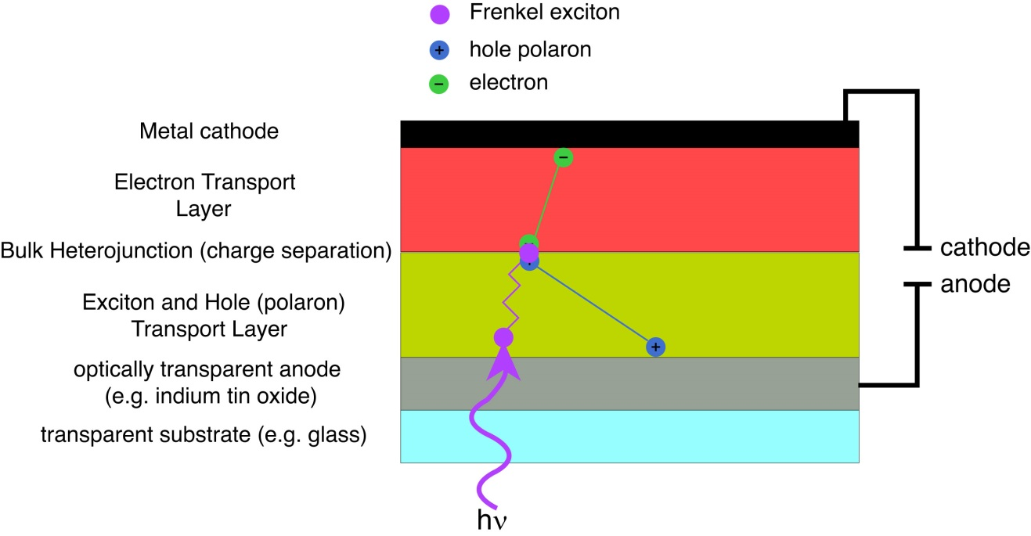

Fig. 1.X. Schematic of a typical organic photovoltaic device depicting exciton generation and exciton, electron, and hole transport.

* 1. **Aggregate Species in CPNs**

Conjugated polymer nanoparticles are comprised of one or more collapsed CP chains. The observed fluorescence emission in the UV-Visible spectrum is due to the structure and heteroatoms that comprise each monomer unit, as well as the extended -conjugation along the polymer backbone. Structural defects introduced upon chain collapse (e.g. bending/kinking of the polymer backbone) break up the conjugation along the polymer backbone, causing differences in the emission characteristics of each locally conjugated segment. This contributes to the broad fluorescence spectra and lifetime heterogeneity observed in CPNs. In addition to the structural defects introduced upon chain collapse, -stacking interactions between closely spaced chromophores lead to the formation of aggregate species. These aggregate species can be in the form of H- or J- aggregates, excimers, or exciplexes. [refs] In CPNs, it is hypothesized that J-aggregates are the predominant aggregate species. The differentiating characteristics between H- and J-aggregates are their spectral shifts and transition dipole interactions. In H-aggregates, the absorption and fluorescence spectra are hypsochromically shifted (shifted toward higher energy or blue-shifted) and the emission spectrum is broad. In contrast, J-aggregates (J- standing for Jelley, who is credited with their discovery) exhibit bathochromically shifted (shifted toward lower energy or red-shifted) absorption and emission, with a narrowing of the emission band and an increase in fluorescence quantum yield. The spectral characteristics of H- and J-aggregates arise from the alignment of their transition dipoles, which arises from their structural alignment or “angle of slippage” (assuming transition dipoles oriented along the long axis of the molecule). This is the angle formed by the long axis of one molecule, and the line connecting the centers of the molecules. For high slippage aggregates (angles < 32°), the transition dipoles are aligned in a head-to-tail orientation, which leads to J-aggregate spectral characteristics. For low slippage aggregates (angles >32°), the transition dipoles are in parallel orientation, leading to H-aggregate spectral characteristics. [ref Jelley, Wurthner review]

* 1. **Fluorescence Anisotropy in Conjugated Polymer Nanoparticles**

Fluorescence anisotropy is used as a means to quantify the extent of polarization of the emission of a fluorophore after being excited by plane-polarized light. Typically, the excitation source is vertically polarized, and the emission is analyzed after being passed through a linear polarizer oriented parallel (0°) or perpendicular (90°) relative to the excitation source. These components of the emission are given by  and , respectively, and the anisotropy *r* is then calculated by

, (1.X)

which essentially forms a ratio of the difference between the parallel and perpendicular emission components relative to the total intensity. Extending this into the time domain, equation and expressing the parallel and perpendicular components of the emission by their polarizer angles for later convenience, 1.X becomes

, (1.X)

where *r*(*t*) is the fluorescence anisotropy decay (FAD), and and are the respective fluorescence intensity decays collected at 0° and 90° polarizer orientations. FAD allows us to quantify the rate at which different processes (e.g. rotation, multiple energy transfer) cause depolarization of the fluorescence signal. It is worth noting that the relative amplitude of  cos2** and sin2**, where ** is the angle of the emission polarizer. When the emission polarizer is set to  = 54.7° (magic angle, ~55°), this results in cos2** = 0.333 and sin2**  , which corresponds to a twofold amplitude of the perpendicular component of the emission relative to the parallel component of the emission, or  [ref Lakowicz]. Thus, it is possible to measure the total intensity *S*(*t*) by magic angle orientation of the emission polarizer, and the anisotropy decay is calculated by

. (1.X)

Structural defects introduced upon nanoparticle formation such as bending or kinking of polymer chains result in many closely-spaced chromophores in varied orientations in space. Thus, it follows that a linearly polarized excitation source (e.g. a pulsed laser) would preferentially excite certain chromophores (those with their transition dipole moments oriented similarly to the polarized excitation pulse). In an aqueous suspension of CPNs, particles are typically large enough (10 nm) that rotational diffusion at room temperature occurs at a rate much slower than the lifetime of the nanoparticles, which allows the assumption that any depolarization of fluorescence can effectively be ascribed to exciton homo-transfer events. As previously discussed, exciton homo-transfer is driven by FRET. Given that the interchromophore distance is minimal (~1 nm) and assuming sufficient spectral overlap, the efficiency of each energy transfer event is then essentially governed by the alignment of transition dipole moments, accounted for in the 2 term in equation 1.X [Forster Radius Eq.], which need not be perfectly aligned for energy transfer to occur. Therefore, each energy homo-transfer event slightly depolarizes the resulting emission (c.f. Fig 1.X). The rate of depolarization, and thus the rate of exciton motion can be probed using picosecond fluorescence anisotropy decay.

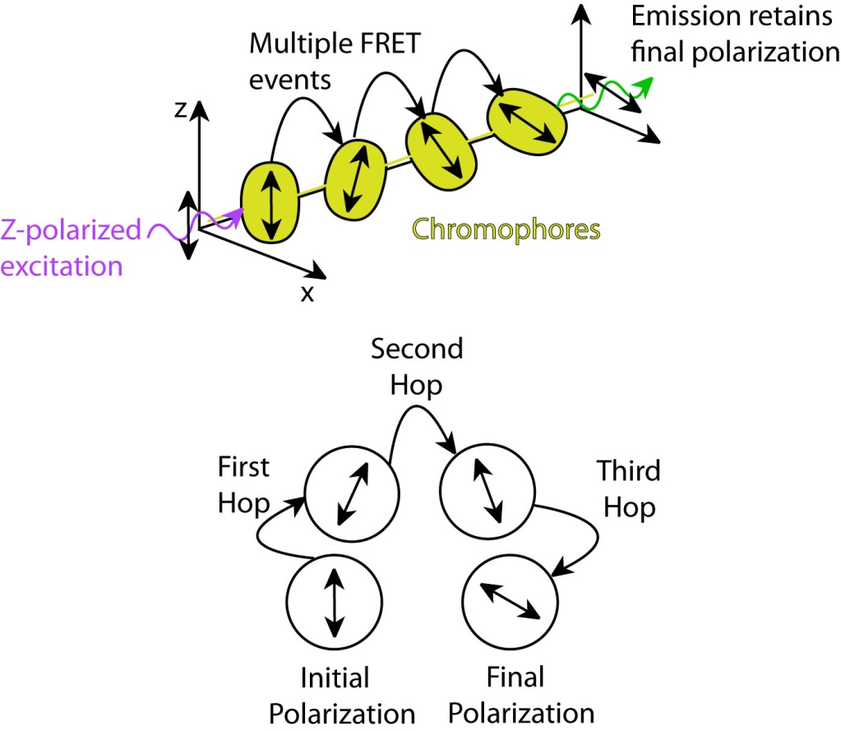

Fig. 1.X. (top) Diagram depicting polarization loss via multiple energy transfer. (bottom) Illustration of polarization changes after each FRET event.

CHAPTER 2

EXPERIMENTAL METHODS

**2.1 Materials**

The two principal fluorescent conjugated polymers used to prepare conjugated polymer nanoparticles (CPNs) in these studies were poly[(9,9-dioctylfluorenyl-2,7-diyl)-*co*-(1,4-benzo-{2,1',3}-thiadiazole)] (PFBT, MW 10,000, polydispersity 1.7), and poly[2-methoxy-5-(2'-ethyl-hexyloxy)-1,4-phenylene vinylene] (MEH-PPV, average MW 200,000, polydispersity 4.0), and were purchased from ADS Dyes, Inc. (Quebec, Canada). The fluorescent dye perylene red (Exalite 613) was purchased from Exciton (Dayton, OH). Polystyrene microspheres, and the fluorescent dye fluorescein were purchased from Life Technologies (Invitrogen, Eugene, OR). The fluorescent dye Lucifer Yellow CH dipotassium salt (LY, 1 mg/mL in water), 3-aminopropyl-trimethoxysilane (APS, 97%), sodium hydroxide (SigmaUltra, minimum 98%), and solvents tetrahydrofuran (THF, anhydrous, inhibitor-free, 99.9%), and ethanol (200 proof, anhydrous, ≥99.5%) were purchased from Sigma-Aldrich (Milwaukee, WI). All materials were used without further purification.

**2.2** **Nanoparticle Preparation**

The method used to prepare fluorescent conjugated polymer nanoparticles is based on a previously described nano-precipitation method. [ref craig 2005 paper] A stock solution of a given conjugated polymer was prepared at a concentration of 1000 ppm (mg/kg) in THF. The polymers were sufficiently dissolved by gentle agitation of the solution at room temperature. For these experiments, the precursor solution to the nanoparticle suspension was prepared by diluting an aliquot of stock solution to a concentration of 20 ppm. For doped samples, dopant fluorescent dyes or polymers were added into the solution in their respective amounts prior to the addition of the diluting solvent that. Typically, dopants were added so that their concentration in the diluted precursor solution was 0.1%–10% by weight, relative to the polymer concentration. The resulting solutions were agitated gently to ensure solution homogeneity. A 2 mL aliquot of precursor solution was then rapidly injected via micropipette into 8 mL of deionized water under bath sonication at a frequency of 40 kHz and room temperature for ~30 seconds.

It is a combination of the very dilute concentration of polymer, and fast injection of the precursor solution that result in nanoparticle formation. It is thermodynamically favorable for a hydrophobic, long-chained molecule like a conjugated polymer to aggregate with itself in water (a poor solvent). Indeed, this is a commonly utilized method of polymer purification [find a ref]. By first dissolving the polymers into a good solvent that is also water-miscible such as THF, it is easier to incorporate the polymers into a poor, mostly aqueous environment, depending on the speed in which it is added. Adding the dissolved polymer into a poor solvent drop-wise results in increased aggregation of the hydrophobic polymer, and any water-soluble impurities remain in solution phase, which are later removed by filtration. This can be confirmed with our polymer samples, as vacuum filtration of a solution in which dissolved polymer is added drop-wise to rapidly mixing water results in the loss of >80% the polymer during the subsequent filtration step. It is by fast injection of the THF solution into rapidly mixing water that local polymer chain collapse occurs as a result of hydrophobic interactions and surface free energy effects. Under these conditions, this occurs at a faster rate that does not allow for flocculation to occur before a given sample of polymer collapses and is moved from its local environment into the bulk solution [Find a ref]. Thus, nanoparticle formation is the kinetically favored product of mixing dissolved polymer into a poor solvent. After nanoparticle formation occurs, the collapsed chain conformation is retained as the remaining THF is removed, resulting in an aqueous colloidal suspension of conjugated polymer nanoparticles. The size of the nanoparticles can be adjusted by increasing the concentration of the precursor solution, which yields a concomitant increase in nanoparticle size.[ref old paper] Typical mean particle sizes range from 4-30 nm, which is verified by atomic force microscope (AFM) image analysis.

The process by which THF was removed from the samples has been refined from our previous partial vacuum evaporation procedure.[cite my first paper] THF was removed by placing the nanoparticle samples in a vacuum oven at room temperature under nitrogen flow for 8-10 hours in order to remove enough THF to prevent bumping during the subsequent partial vacuum evaporation step. Nitrogen flow was ceased and samples were evaporated under vacuum for 6-7 hours at a temperature of ~40 °C to remove most of the remaining THF. The total volume of liquid was reduced by ~60% during the evaporation process, which was confirmed to be sufficient by an iterated Raoult’s Law calculation, the results of which yield that <1% THF exists at ~40% volume loss. No residual THF odor was detected in the samples. Additionally, further evaporation yielded no further change in the fluorescence spectrum or quantum yield. The samples were subsequently vacuum filtered through a glass fiber prefilter and a 0.1 µm PVDF membrane filter in order to remove larger aggregates. The resulting suspensions are clear (not turbid) and stable, showing no signs of aggregation for months.

**2.3 Characterization Methods**

Several techniques are employed in order to characterize our nanoparticle samples. These include atomic force microscopy (AFM), UV-Vis spectroscopy, steady-state fluorescence spectroscopy, and fluorescence quantum yield measurement.

**2.3.1 Atomic Force Microscopy (AFM)**

Nanoparticle size distributions are determined with an Ambios Q250 multimode AFM in intermittent contact (AC or tapping) mode. In all modes of AFM imaging, a cantilever with a sharp probe tip is raster-scanned across a sample immobilized on a glass coverslip or other substrate. In tapping mode, the cantilever is vibrated at a frequency close to the resonant frequency of the cantilever material (70-200 kHz), and at constant amplitude by a piezoelectric element on the AFM tip mount. As the cantilever is brought into proximity of a sample during the raster scan, the forces acting on the cantilever are dampened by the periodic contacts between the tip and the sample, reducing the amplitude of cantilever oscillations. The cantilever oscillations are monitored by a laser reflected off of the cantilever onto a quadrant photodiode detector. The probe height is adjusted by a separate piezoelectric element within the AFM head, and the changes in height are controlled by an electronic feedback loop coupled to the quadrant photodiode detector output. This works to restore the amplitude of the cantilever vibration once the oscillation amplitude moves above or below an adjustable set point amplitude. The image is produced line-by-line by translating the changes in probe height into a topographic image of the sample. Particle sizes are determined by analyzing the peak z-heights of each viable particle in the image and constructing a histogram to determine the mean and standard deviation of the particle sizes.

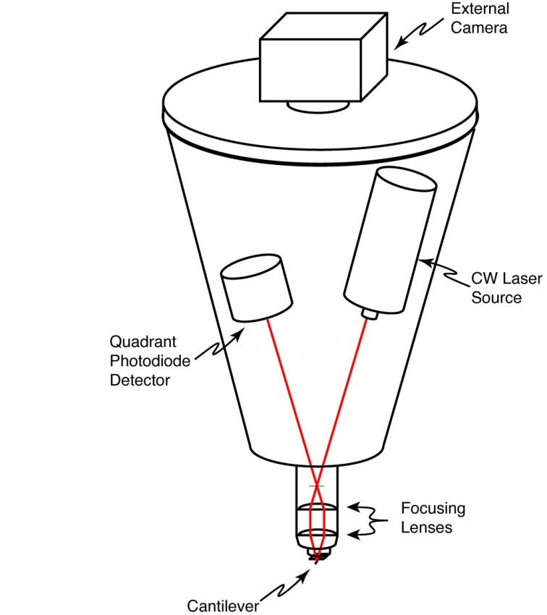

Fig. X. Simplified schematic of a typical AFM head.

AFM samples were prepared by a dip-casting procedure. First, a cleaned, dry glass coverslip was amine-functionalized with 70 µL of freshly prepared 5×10-4 M APS in anhydrous ethanol. The solution was left on the coverslip for 3 minutes, followed by rinsing the coverslip with deionized water, and blowing it dry with nitrogen. An aliquot of the nanoparticle suspension was diluted by 30-40 times in a small beaker, and the coverslip was submerged into the diluted suspension with the functionalized side up for 40 minutes. The coverslip was then carefully removed from the solution and allowed to dry completely in a vacuum oven at room temperature. To prepare the sample for AFM use, the coverslip was fixed to a glass slide with thin strips of tape.

There are several factors that impact the quality of an AFM image, including tip wear or breakage, as well as improper tuning of the PID (Proportional, Integral, and Differential) feedback loop. It is not possible to extract accurate particle size information from the diameters of the particles in the x-y plane due to tip convolution effects between the sample surface and the tip, which distort the image in the x-y plane. The sharper the tip is, the smaller this effect is. As the tip wears and becomes blunted, this convolution effect is exacerbated, making the particles appear larger in the x-y plane. If foreign matter (e.g. dust, dirt) is stuck to the tip, or the tip is broken as a result of crashing the tip into the sample substrate, this can yield false duplicate particles in the image (for every particle in the image). Improper setting of the PID feedback loop can result in cantilever hysteresis, in which the change in z-height needed to restore the cantilever oscillations to the set point value is overshot (or undershot) compared to the actual change required to restore the oscillations to the set point value. This translates into improper z-height values, and the potential to have the probe tip either scratch the sample or crash into the sample or substrate, damaging the probe tip.

**2.3.2 UV-Vis/Absorption and Fluorescence Spectroscopy**

UV-Vis absorption spectra were collected on a Shimadzu UV2101PC scanning spectrophotometer using 1 cm quartz cuvettes. The absorption spectra were used to determine the nanoparticle concentration and peak absorption wavelength corresponding to the HOMO-LUMO electronic transition. For fluorescence measurements, concentrated nanoparticle samples (peak absorbance between 0.2–0.4) were diluted to yield a peak absorbance of ~0.1 for collection of fluorescence spectra or fluorescence lifetime measurement. Samples were diluted to an absorbance of ~0.05 for fluorescence quantum yield measurement. Steady-state fluorescence spectra were collected using a commercial fluorescence spectrometer (Quantamaster, Photon Technology International, Inc.) with 1 cm cuvettes. Samples were diluted to an absorbance of ~0.1 AU or less at the relevant excitation wavelengths. To avoid saturation of the photomultiplier tube (PMT) detector, all slit widths were kept at 0.50 mm. The acquisition time was set to 1 s/nm to reduce noise in the spectra.

It is important to ensure sufficient dilution of fluorescent samples in order to avoid the inner filter effect, in which a photon emitted by one molecule is reabsorbed or scattered by another molecule in close proximity. An important note about the inner filter effect is that it is not limited by sample concentration alone in CPNs. Particle size must also be considered in this case, since it is possible to prepare nanoparticles with diameters that exceed the optical penetration depth of the material. The optical penetration depth (or optical skin depth) of a material can be determined by , where **(**) is the absorption coefficient of the material at wavelength **, *A*(**) is the absorbance at wavelength **, and *d* is the thickness of the material. Optical penetration depths range from tens of nanometers to several microns, depending on the material. Typical values for conjugated polymers range from ~40 nm to ~400 nm. [refs] Since CPNs are comprised of multiple closely-spaced chromophores, it is possible for a photon to be emitted from a chromophore on one end of a large particle, transmit through the particle, and be reabsorbed by another chromophore at the opposite end. This is one of the reasons why vacuum filtration is used to remove larger aggregates from the nanoparticle suspensions prior to measuring their fluorescence.

**2.3.3 Fluorescence Quantum Yield**

The fluorescence quantum yield (QY or PLQY) of the CPN samples was determined in several steps. First, an appropriate standard fluorophore must be selected with an absorption and emission maximum similar to the conjugated polymers under study. In this work, the standard fluorophores used were fluorescein dissolved in 0.01 M sodium hydroxide, and Lucifer Yellow CH dissolved in water (LY). A common absorption wavelength was selected between the sample and standard (473 nm for fluorescein, 450 nm for LY), and solutions were prepared at an absorbance of ~0.05 AU at the common absorption wavelength. Emission spectra were collected at the common excitation wavelength, and the fluorescence quantum yield is calculated by the expression

, (2.1)

where, *F*,*s* is the fluorescence quantum yield of the standards (0.92 for fluorescein in 0.01 M NaOH and 0.22 for LY), *F,x* is the fluorescence quantum yield of the sample, *A* is the absorbance, *I* is the integrated fluorescence intensity, and *n* is the refractive index of the solvent. It is important to note that a solvent blank must be measured for both absorbance and fluorescence measurements in order to properly apply baseline correction to the spectra when calculating the fluorescence quantum yield.

**2.4 Picosecond Time-Correlated Single Photon Counting Spectroscopy (TCSPC)**

**2.4.1. Basic Instrument Operation**

Picosecond fluorescence lifetimes were measured under nitrogen using a home-built setup for time-correlated single photon counting (TCSPC) spectroscopy operating in either forward or reverse mode. Frequency doubled pulses (420 nm) from a passively mode-locked Ti:Sapphire laser (Coherent Mira 900, 840 nm pulses, ~150 fs pulsewidth) were used as the excitation source for the nanoparticle samples. Fluorescence was collected perpendicular to the excitation source and passed through a 460 nm long pass filter, and a calcite Glan-Taylor polarizer (Thorlabs, GT10-A) oriented at magic angle (55°) to the vertically polarized excitation pulses. For TCSPC measurement, the polarizer is oriented at 55° (magic angle) since the intensity decay collected at this orientation corresponds to the sum of the fluorescence intensity in the x, y, and z planes, given by , as previously discussed. The output of a single photon avalanche photodiode (APD, id Quantique, id100-50) was used as the start timing pulse for a time-to-amplitude converter (TAC, Canberra Model 2145), and the output of a fast PIN diode (Thorlabs, DET210) was used as the stop pulse, in a standard reverse-mode configuration.{Schaffer, 1999 #88;Cross, 1984 #87} In forward-mode TCSPC, the detector outputs to the TAC are switched. The excitation power was attenuated (between ~300 µW and 1 mW, typ.) to maintain a count rate of ~400 kHz as measured at the APD. The analog TAC output was digitized using a multi-channel analyzer (FastComTec, MCA-3A).

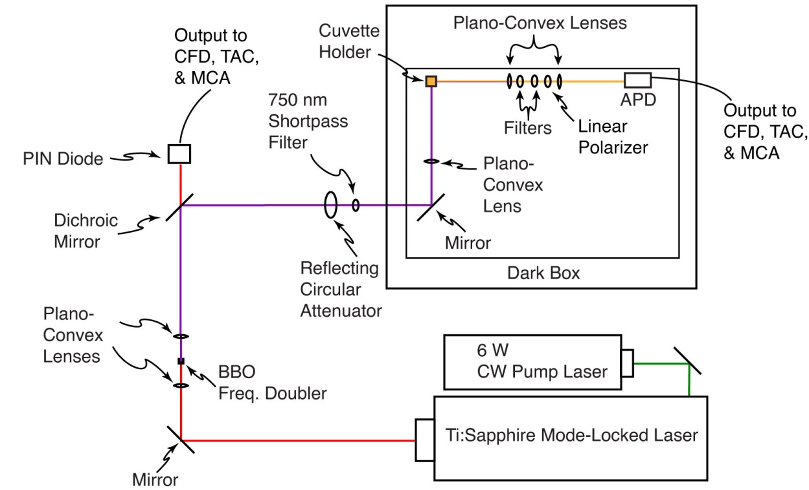

Fig. X. Time-Correlated Single Photon Counting and Fluorescence Anisotropy Decay setup.

Before and after each measurement an instrument response function (IRF) was measured using scattered excitation light from a dilute suspension of polystyrene microspheres. The width of the IRF was determined to be ~70 ps (fwhm). Typical peak signal-to-noise ratios (SNR) for each run were between 200:1-500:1 in reverse mode, and 50:1-100:1 in forward mode. Due to the random nature of photon arrival, the SNR is determined from the Poisson probability distribution function (PDF), given by

, (2.X)

Where ** is the mean of the distribution of photon arrival times and *N* is the number of photon arrival events. The SNR is approximated by the standard deviation of the distribution as  (e.g. 10,000 photon counts at the peak results in a peak SNR of 100:1).

**2.4.2 Validation of the TCSPC Instrument**

For the technique of time-correlated single photon counting (TCSPC), there are several sources of artifacts, including afterpulsing in detectors, stray reflections in the apparatus, improper triggering (e.g., triggering on a ring instead of on the principal pulse), and signal reflections and nonlinearities in the timing and readout electronics. As such, precautions must be taken to ensure that data being collected in these experiments is of the highest possible quality. The instrument was carefully aligned, and baffles were employed to minimize stray light. Discriminator levels were adjusted to minimize the width of the instrument response function and minimize ringing. Proper impedance matching was employed. While there is a slight ring apparent in results obtained for samples with lifetimes greater than ~2 ns (c.f. Fig 3 in main text), we have validated the accuracy of the instrument using several standard dyes, including fluorescein in 0.01 M NaOH (τ = 4.1 ns),4 coumarin 6 in ethanol (τ = 2.5 ns),5 and perylene red in THF (τ = 5.6 ns).3 All lifetimes measured were within 10% of the literature values, indicating that the ringing, while visible, has a negligible effect on the lifetime results obtained.

**2.5 Picosecond Fluorescence Anisotropy Decay (FAD)**

Fluorescence anisotropy decay (FAD) measurements were performed using the aforementioned TCSPC setup, with the addition of a calcite Glan-Taylor linear polarizer (Thorlabs GT-10A) placed after the filter set, and before the focusing lens. For fluorescence anisotropy decay measurement, intensity decays and IRFs were collected at all three polarizer orientations. Unlike TCSPC, the excitation power is attenuated once and then held constant rather than variably attenuated for each sample in order to avoid systematic deviations in the anisotropy signal due to inconsistent excitation power. The excitation power is selected so that the collected emission at each polarizer orientation yields a count rate between 200 kHz and 800 KHz as measured on the APD. Typically, the strongest emission is collected when the emission polarizer is parallel to the excitation. Details of the FAD least-squares fitting analysis will be given in Chapter 4.

CHAPTER 3

MEASUREMENT OF EXCITON TRANSPORT IN DYE-DOPED AND BLENDED CONJUGATED POLYMER NANOPARTICLES

Reprinted (adapted) with permission from Groff, L. C., Wang, X. and McNeill, J. D. *J. Phys. Chem. C* **2013**, 117, 25748-25755, and Wang, X., Groff, L. C., and McNeill J. D. *J. Phys. Chem. C* **2014**, 118, 25731-25739. Copyright 2013, 2014 American Chemical Society.

**3.1 Introduction**

In recent years, there has been a great deal of interest in conjugated polymers, largely due to their application as the active materials in flexible, low-cost, highly efficient photovoltaic{Dennler, 2005 #1261} and light-emitting devices.{Yim, 2008 #1303} Conjugated polymer nanoparticles (CPNs) are of interest for use in biological imaging, given their high fluorescence brightness, extraordinary two-photon fluorescence cross-sections, and excellent photostability.{Wu, 2007 #1302;Yu, 2009 #1304;Wu, 2009 #1298;Wu, 2008 #1299;Wu, 2010 #1301;Wu, 2013 #1300;Koner, 2013 #1276} It is increasingly clear that further development of applications requires additional understanding of the complex photophysics and photochemistry of conjugated polymers, as well as their dependence on polymer structure and processing conditions. In organic semiconductors, the principal neutral electronic excitation of interest is typically the Frenkel-type singlet exciton.{Emelianova, 2010 #1265},{Kasha, 1965 #1273} Energy transfer between sites or chromophores occurs via multiple processes, including incoherent, diffusion-like processes,{Lunt, 2009 #1279;Gammill, 1974 #1266;Powell, 1969 #1287} dispersive transport,{Athanasopoulos, 2013 #1256} and in some cases, via ultrafast, long range coherent transport.{Scholes, 2006 #1288} In the exciton diffusion picture, each polymer chain is considered to consist of several more or less independent chromophores or exciton sites, and excitations transfer from one site to other nearby sites via transition dipole-mediated Förster transfer.{Burkalov, 2005 #1258} Multiple excitation transfer events typically occur during the excited state lifetime, resulting in a random walk-like process characterized by a diffusion constant or length. A large exciton diffusion length is required for optimum photovoltaic device efficiency (for some device types), since excitons must travel to the heterojunction to undergo charge separation. While the exciton diffusion length in high purity, crystalline inorganic semiconductors can reach several microns,{Gregg, 1997 #1267} it is typically much shorter for organic semiconductors. For example, measured exciton diffusion lengths for single crystals of anthracene range from ~30 nm to 60 nm,{Donati, 1978 #1263;Mulder, 1967 #1285;Simpson, 1957 #1290} and diffusion lengths of under 15 nm are typically reported for conjugated polymers.{Lyons, 2005 #1280;Wu, 2008 #1297;Tousek, 2012 #1294} Interacting chromophores can also give rise to aggregate species such as dimers, H- and J-aggregates, excimers, and exciplexes.{Jelly, 1936 #1271},{Hayer, 2012 #1268} Energy transfer can also occur to these and other species such as excess charges (polarons),{McNeill, 2002 #1282} defects introduced during polymer synthesis or processing,{Hintschich, 2003 #1269} or dopant species such as dyes and other polymers.{Wu, 2008 #1297;Wu, 2006 #1296} These processes can significantly reduce the observed exciton diffusion length. Various experimental methods have been developed for characterizing exciton diffusion, including photoluminescence quenching in layered structures,{Lunt, 2009 #1279;Hofmann, 2012 #1270} confocal fluorescence microscopy,{Kelbauskas, 2003 #1274} near-field fluorescence microscopy,{McNeill, 2000 #1284;Adams, 1999 #1255;Credo, 2001 #1260} time-resolved fluorescence of dye-doped films, crystals, or nanoparticles,{Powell, 1969 #1287;Lyons, 2005 #1280;Wu, 2008 #1297;Marciniak, 2012 #1281} and single particle imaging.{Bolinger, 2011 #1257},{Yu, 2012 #1305} Different assumptions are involved in the various methods, each contributing to different types of systematic error or bias, leading to a wide range of reported exciton diffusion lengths, as discussed by Forrest *et al*.{Lunt, 2009 #1279}

Here, we examine some processes relevant to the determination of exciton diffusion constants in dye-doped conjugated polymer nanoparticles by way of time-resolved fluorescence spectroscopy. In particular, we examine the effects of quenching by defects on the observed quenching efficiencies and excited state dynamics. While quenching by defects{Hintschich, 2003 #1269} and hole polarons{Yu, 2012 #1305} has been observed, quenching by defects is rarely quantified in studies of exciton transport dynamics in conjugated polymers, perhaps since it is preferable to minimize defects by employing proper technique. However, in some cases defects can be difficult to avoid entirely, or there may be quenching by intrinsic species such as aggregates, exciplexes, or photogenerated polarons. Furthermore, the combination of energy transfer and exciton diffusion can result in quenching radii as large as 10 nm.{McNeill, 2004 #1283} Thus, even very low concentrations of defects or other quenching species could give rise to significant quenching. Additionally, quenching by hole polarons is significant at a polaron density of 5x1017 cm-3,{McNeill, 2002 #1282;Deussen, 1995 #1262} which is often exceeded in functioning devices. We observe complex fluorescence decay dynamics consistent with significant quenching by defects in undoped nanoparticles of MEH-PPV and PFBT. Therefore, we develop a modified approach to determining exciton diffusion parameters that explicitly includes quenching by defects. By fitting the quenching efficiencies and complex fluorescence decay kinetics to an exciton diffusion model that explicitly includes quenching by defects, we obtain a corrected exciton diffusion length for nanoparticles of the polymer PFBT. Our results indicate typical analysis ignoring defects results in underestimation of *LD* by roughly a factor of 2. Analysis of the distribution of lifetimes provided additional confirmation of quenching by defects: The fluorescence decays of doped and undoped particles were fit to a stretched exponential function, yielding a stretch parameter **, which typically varies between ~0.3, indicating a broad distribution of lifetimes, and ~1.0, indicating a very narrow distribution (a single lifetime). Fitting the dynamics of undoped particles yielded ** = 0.6, consistent with significant quenching by defects. Analysis of the radiative and non-radiative rates was also consistent with quenching by defects. Our results indicate that quenching by defects can lead to significant underestimation of the exciton diffusion length, particularly for highly mobile excitons, which are highly susceptible to quenching, even at very low densities of quenching species or defects. The results are also promising for applications requiring highly mobile excitons, such as photovoltaic devices, since improvements in exciton diffusion length by a factor of 2 or more are expected if quenching by defects can be substantially reduced.

**3.2 Doped Nanoparticle Preparation Details**

Dye doped and blended conjugated polymer nanoparticles were prepared using the method described in Chapter 2.2. The specific details pertaining to the doping procedure are given as follows. Varying amounts of the dopant perylene red solution were mixed with the PFBT solution to produce solution mixtures with a concentration of 20 ppm PFBT and dopant/host fractions of 0 to 2 wt% perylene red. The mixtures were sonicated very briefly (3-5 s) to ensure homogeneity. For blended nanoparticles, varying amounts of dopant polymer MEH-PPV solution were mixed with a solution of host polymer PFBT solution to produce mixture solutions with a total polymer concentration of 20 ppm and a ratio of MEH-PPV/PFBT ranging from 0% to 10 wt %. A 2 mL quantity of each solution mixture was added rapidly to 8 mL of deionized water under sonication for ~30 s at a sonication frequency of 40 kHz and room temperature.

**3.3 Characterization Methods**

Size distributions and morphologies of undoped and perylene red doped PFBT nanoparticles were determined by atomic force microscopy (AFM). Samples were prepared by functionalizing the surface of a freshly cleaned glass coverslip with 3-aminopropyl-trimethoxysilane in anhydrous ethanol, followed by dipping in a diluted nanoparticle suspension for 40 minutes, then removing the coverslip and allowing it to dry overnight in an enclosed environment. Surface topographies were measured on an Ambios Q250 multimode AFM in tapping mode. As shown in Figure 1 in the main text, the mean diameter of the CPNs was 8 ± 2 nm. All of the perylene red doped PFBT CPN samples showed no substantial changes in mean diameter, with a similar size distribution.

UV-Vis absorption spectra were collected on a Shimadzu UV2101PC scanning spectrophotometer using 1 cm quartz cuvettes. Fluorescence spectra were collected and fluorescence quantum yield was measured using a commercial fluorimeter (Quantamaster, Photon Technology International, Inc.) using 1 cm quartz cuvettes. The UV-Vis spectra showed no variations from the undoped spectrum over the range of doping, and the absorbance of perylene red was well below the limit of detection of the instrument in the CPN suspensions. The fluorescence spectra of the CPN samples are given in Figure 2 in the main text. The decreased lifetimes of the particles as compared to the polymer in good solvent are not likely to be due to J-aggregate formation, since little shift in the polymer absorption spectrum is observed upon nanoparticle formation (c.f. Fig. S1).

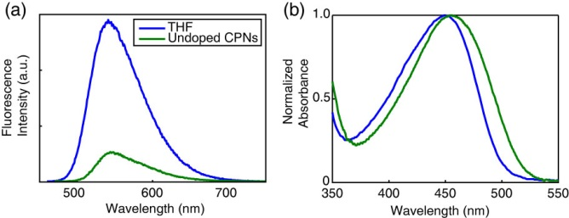

**Fig. S1.** (a) Fluorescence spectra and (b) normalized absorbance spectra of PFBT in THF (blue) and undoped PFBT CPNs (green).

The standard fluorescent dye fluorescein in 0.01 M sodium hydroxide was utilized to determine the fluorescence quantum yield of the PFBT CPN samples. 473 nm was selected as the excitation wavelength. The concentrations of the standard and nanoparticle suspensions were adjusted to yield an absorbance of ~0.05 at 473 nm. The absorbance, integrated fluorescence, and refractive indices of the sample and standard solutions were used in conjunction with the literature value of 0.92 for the quantum yield of fluorescein in 0.01 M sodium hydroxide to calculate the fluorescence quantum yield of the nanoparticle suspensions.2 The results of the quantum yield measurements are given in Figure 2 in the main text. A Förster radius of 3 nm for the PFBT/perylene red donor/acceptor pair was calculated utilizing the absorption spectrum of perylene red in THF and the emission spectrum of undoped PFBT CPNs using standard methods,{Lakowicz, 2006 #1277} correcting for the polymer refractive index and assuming an orientation factor of , which is the standard result for dynamic reorientation of transition dipoles.

Fluorescence lifetimes were measured in air using the TCSPC method described in Chapter 2, with the instrument running in forward mode. Nanoparticle fluorescence was collected perpendicular to the excitation source after passing through a 460 nm long pass filter for the undoped nanoparticles. An additional 540 ±10 nm band pass filter was added for the doped samples in order to filter out the emission from perylene red. The excitation pulse was attenuated to maintain a valid start/stop event count rate of ~6 kHz. Several TCSPC kinetics traces were obtained for each sample. Data was acquired until roughly 103-104 photons had been collected. Typical signal-to-noise ratios were above 50:1 for the samples and 100:1 for the IRF.

**3.4 Initial characterization of dye-doped PFBT CPNs.**

Doping of conjugated polymer nanoparticles (CPNs) with dyes is being pursued as a strategy for improving their brightness and photostability while red-shifting their fluorescence, and as a way to investigate exciton diffusion in conjugated polymers. PFBT was selected as the host polymer owing to its excellent photostability and high fluorescence quantum yield, as well as its broad fluorescence spectrum, which facilitates energy transfer to dyes.{Wu, 2008 #1299} Perylene red was selected as the dye dopant for this system due to the excellent spectral overlap with the emission spectrum of PFBT and its high fluorescence quantum yield (0.96 in chloroform).{Brouwer, 2011 #1311;Seybold, 1989 #1312} Perylene red-doped PFBT CPNs were prepared via a nano-precipitation method described previously.{Szymanski, 2005 #1291} Samples were filtered through a 0.1 µm membrane filter and characterized via UV-Vis and fluorescence spectroscopy. Size distributions were determined via particle height analysis of representative AFM images (c.f. Fig 1). The AFM images are consistent with spherical nanoparticles, as is expected for glassy polymers in this size range, based on surface free energy considerations. Terentjev et al. previously reported spherical morphology for particles of PFBT roughly in this size range.{Yang, 2005 #1306}

Energy transfer efficiency as high as 86% was observed at 2% doping, where the energy transfer efficiency is given by **, and *F, F0* are the host fluorescence intensity in the presence, absence of dopant, respectively (c.f. Fig 2). It was expected that most of the dye is incorporated into the nanoparticles owing to the hydrophobic character of the dye, based on previous results examining incorporation of dyes with similar solubility properties, using centrifugal concentration to examine dye incorporation and possible leaching.{Wu, 2008 #1297} Additionally, the lack of additional features in the UV-vis and fluorescence spectra that could be ascribed to free dye or dye aggregate in solution is evidence that the fraction of unincorporated dye is small (less than a few percent). Finally, the high energy transfer efficiency at low doping ratios provides additional confirmation that a high fraction of the dye molecules are incorporated in the nanoparticles. The intensity of acceptor emission in the doped samples increases as dopant is added up to 0.5% doping. Upon further doping, acceptor emission intensity decreases. We ascribe this to aggregation quenching of the acceptor as dye dimers form within the nanoparticle at higher doping levels. Aggregate formation could also explain the red shift of the acceptor emission observed at higher doping levels. Stern-Volmer analysis was performed using the quencher/donor molecular fraction *f* = *ndye*/*npoly* as the unit of concentration, in order to obtain *KSV* in terms of the number of polymer molecules quenched per perylene red molecule. The analysis yields a quenching constant of 37 per dye molecule, indicating that roughly 37 PFBT molecules are quenched per dye molecule. From this result, an effective dye quenching radius of 5.3 nm is obtained, which is significantly larger than the calculated Förster radius, providing initial indication of exciton diffusion.

The quantum yield of undoped PFBT CPNs was measured to be 0.14, consistent with prior measurements.{Wu, 2008 #1299},{Tian, 2010 #1292;Tian, 2013 #1293} The total fluorescence quantum yield of the doped samples decreases monotonically with increasing dopant concentration, indicating that doping with this dye does not increase CPN brightness as initially hoped (c.f. Fig 2). However, at moderate doping levels (0.5%-1%), the decrease in fluorescence quantum yield is minimal, while the energy transfer efficiency is high, thus doping with perylene red can be used to red-shift the fluorescence while maintaining high levels of brightness. In microscopic imaging experiments, signal levels and contrast are affected by several phenomena and factors related to the spectroscopy of the dyes and the experimental setup.{Ntziachristos, 2006 #1286} A key issue is autofluorescence from the sample and from the various optical materials. Autofluorescence typically peaks a few nm to the red of the excitation wavelength, with a long red tail. Thus, for typical dyes with small Stokes shifts, selection of filters involves a compromise between efficient collection of the emission of interest and rejection of autofluorescence. The PFBT nanoparticles doped with perylene red exhibit a large red-shift in the emission, which is advantageous for efficient collection of fluorescence and rejection of autofluorescence.

The effect of quenching by molecular oxygen on the quantum yield of the undoped PFBT CPN samples was assessed by purging the sample with nitrogen in the dark for 45 minutes prior to measurement. The quantum yield in air was measured to be 0.097, and 0.100 in nitrogen. The differences in quantum yield for the sample in air compared to the data in Figure 2 are not statistically significant, indicating negligible fluorescence quenching by oxygen.

**3.5 Picosecond time-resolved fluorescence spectroscopy**

Time-correlated single photon counting (TCSPC) was employed to determine the lifetimes of the excited state in doped and undoped nanoparticles of PFBT, and for the polymer dissolved in THF. The decay trace was fit by a least-squares minimization procedure involving convolution of a trial decay function with the instrument response function. The trial functions are (single) exponential, bi-exponential, and the stretched exponential or Kohlrausch-Williams-Watts (KWW) function,

. (1)

The stretch-parameter ** acts as a measure of lifetime heterogeneity, ranging between ~0.3 and 1, where lower values indicate a broad distribution of lifetimes while ** = 1 corresponds to a single lifetime.{Chen, 2003 #1259}The fluorescence decay of PFBT in THF was adequately fit by a single exponential, while the decays of undoped nanoparticles and lightly to moderately-doped particles (0.1%-1.0%) exhibited complex decay kinetics that fit well to both bi-exponential and stretched exponential (KWW) functions. While single exponential fits converged for all samples, bi-exponential and KWW fits did not converge for 1.5% and 2% doping due to low signal levels and short lifetimes relative to the width of the instrument response function. Results show a clear decreasing trend in lifetimes as the doping ratio is increased, with perhaps a slight decreasing trend in ** (c.f. Fig 3), though it is not clear that the decrease is statistically significant. In any case, the ** values indicate a broad distribution of exciton lifetimes for the nanoparticles, consistent with energy transfer in dense multichromophoric systems,{Wu, 2008 #1297} while the polymer in THF yielded ** values near unity, suggesting little energy transfer. Overall, the weighted average lifetimes and ** values obtained from the fits are consistent with the physical picture of exciton diffusion and energy transfer, i.e., dynamic quenching due to energy transfer, which will be discussed in more detail below.

Fitting was performed using a set of custom MATLAB scripts. Briefly, the fitting procedure is as follows. The model function consisted of either a single exponential, a bi-exponential, or a KWW decay function. Conventional gradient-based nonlinear least squares minimization methods such as Levenberg-Marquardt often fail for multi-exponential fitting, so an alternative approach was employed. A random number generator was used to generate a series of guesses for the nonlinear parameters (including shifts in *t0*, since small shifts in timing can occur due to drift) over a selected range. Then, for each set of nonlinear guess parameters, the trial fit function is convolved with the instrument response function and the linear parameters (i.e., the exponential amplitudes) are determined by linear least-squares. The sum of the square of the residuals (square error) for the set of parameters is calculated and compared to the minimum square error obtained thus far. If the new value is lower, then the parameters and the square error are saved. After several thousand iterations, the set of parameters corresponding to the minimum square error is taken as the set of best-fit parameters. The soundness of the fit is tested by additional sets of iterations with both wider and narrower ranges for the guesses, and by visual inspection of the residuals. Additionally, the range of data included in the fitting analysis, as well as the degree of downsampling of the data were varied, and the effect on the resulting fit parameters was evaluated. The fitting results for several TCSPC kinetics traces for each sample were used to determine the mean and standard deviation of the parameter values. Typical standard deviations of better than 10% were obtained for the lifetime values.

The effect of quenching by molecular oxygen on the lifetime of the nanoparticle samples was also assessed by comparing the lifetime results obtained for samples exposed to air with those obtained from nitrogen-purged samples. The bi-exponential weighted average lifetimes of the undoped PFBT CPNs were measured to be 780 ps in air and 850 ps in nitrogen. This difference is not statistically significant, and is in agreement with the quantum yield measurements indicating minimal quenching by oxygen.

In addition to the lifetimes of the host polymer PFBT, the lifetimes of the acceptor perylene red were measured. The lifetime of perylene red in THF was measured to be 5.4 ns, which is consistent with the literature value.3 The moderate to heavily doped samples of PFBT nanoparticles were selected due to the relatively low contribution to the emission signal by PFBT as well as to assess the effect of the observed self-quenching of perylene red on its lifetime in the nanoparticles. The lifetime of perylene red doped within the nanoparticles was found to be reduced to 3.1 ns, and follows a decreasing trend as doping increases. The reduction in lifetime indicates dynamic self-quenching.

|  |  |
| --- | --- |
| **Perylene Red %(w/w)** | **τexp (ns)** |
| **THF** | 5.4 |
| **1.0%** | 3.1 |
| **1.5%** | 2.9 |
| **2.0%** | 2.6 |
|  | |

Table 3.1. Fluorescence lifetimes of the energy acceptor fluorescent dye Perylene Red in THF and in dye-doped PFBT CPNs.

**3.6 Modeling Exciton Diffusion and Energy Transfer in Dye-Doped CPNs**

Exciton dynamics in doped conjugated polymers can be described as mobile excitons hopping from site to site in a random, diffusion-like process prior to decaying (both radiatively and non-radiatively) or undergoing energy transfer to a defect or dopant molecule.{Tvingstedt, 2010 #1295;Simas, 2010 #1289;Dykstra, 2009 #1264} In this picture, a key exciton transport parameter is the diffusion length, , where *n* is the dimensionality, *D* is the (1D) diffusion constant, and ** is the exciton lifetime. We previously developed a numerical random walk approach to modeling the combined effects of exciton diffusion and energy transfer in CPNs, which yielded values for energy transfer efficiency that were in agreement with experimental results for dye-doped CPNs.{Wu, 2008 #1297} This approach was also applied to modeling fluctuations in the fluorescence centroid of a single CPN due to polaron motion.{Yu, 2012 #1305} Here, we have modified the previous simulation code to provide kinetics information for comparison to the time-resolved fluorescence results. We have also modified our approach to explicitly account for quenching by defects. Neither coherent transport nor dispersive transport are explicitly included in the present approach.{Athanasopoulos, 2013 #1256;Scholes, 2006 #1288} The simulation algorithm is described as follows. The simulation code was written as a set of MATLAB scripts. Dopant dyes and/or defects are distributed randomly within the nanoparticle, represented by a sphere. While a sphere is assumed, similar results are obtained assuming a cubic particle.{Yu, 2012 #1305;Bolinger, 2011 #1257} Here we define “defects” as any of a number of quenching species such as polarons, aggregate species, conformational defects, oxidized defects and synthetic defects, which are not deliberately introduced into the system, in contrast to the dye molecules, which are deliberately added in controlled amounts. In these simulations, dopant dyes are essentially treated as points within a continuum. However, the model may be adjusted to correct for finite dye volume effects (e.g. by adjusting the Förster radius). It is expected that the addition of an exclusion volume would have a minimal impact on the quenching dynamics and on the quenching efficiency, since the volume of the dye is less than 2% of the nanoparticle volume. Similarly, the dye volume is smaller than the quenching volume by a factor of 20 or more. Finally, we note that in previous simulations,{Wu, 2008 #1297} we employed a discrete lattice model, and found that the quenching efficiency obtained was not sensitive to the lattice spacing, for lattice spacing of 0.1 to 0.4 nm, which is consistent with the reasoning above. An initial population of excitons is also distributed randomly within the sphere. For each time step *t*, each exciton is propagated by adding to its position along each axis a Gaussian-distributed random number scaled so that *2=2Dt*, where *D* is the (1D) diffusion constant and *2* is the variance of the random number distribution (** = 0). A time step *t* of 1 ps was employed, and time steps of 0.2 ps, 0.5 ps, 2 ps, and 5 ps were also tested, to help ensure that the simulation results were not significantly affected by numerical rounding errors or using a step that is too large given the various rates and diffusion distances involved. At each step, the new positions are checked to ensure that the exciton remains within the sphere representing the particle, and the jump is reversed for excitons that are outside the sphere, thus ensuring that the excitons remain within the sphere. The energy transfer rate, for each exciton to each dopant or defect, is calculated based on the exciton-acceptor distances and the conventional Förster rate expression,

. (S.2)

The probability of decay or transfer for a given exciton during the time step Δ*t* is calculated by the expression

 (S.3)

where *k* is given by either , or *ket*, and compared to a random number to determine the exciton fate for that time step. The running total of excitons that have decayed via energy transfer is updated (for later use in determining the quenching efficiency), and the exciton population is updated (for later use in constructing a simulated kinetics trace), for each time step. The simulation continues until nearly all of the exciton population has decayed. The simulations are performed for many initial random configurations of acceptors and excitons, and the exciton population kinetics and energy transfer efficiencies are calculated from the simulation results.

We explicitly include exciton quenching by defects (which can include aggregates, polarons, excimers, synthetic defects, oxidized defects, etc.) as a key feature in our approach to modeling exciton diffusion and energy transfer in the nanoparticles. The explicit inclusion of quenching by defects is based on several observations. First, the fluorescence quantum yield and excited state lifetime of the nanoparticles is greatly reduced ( = 0.14,  = 800 ps) as compared to the polymer in a good solvent such as THF ( = 0.66,  = 3000 ps). The phenomenon of reduced lifetimes in the aggregated state is often observed in J-aggregates, and is typically described as due to coupling of the transition dipole moments that causes a large increase in the radiative rate.{Kometani, 2000 #1275} However, strong J-aggregate-type coupling is not likely to be responsible for the decrease in lifetime in the present case, since little shift in the absorption spectrum is observed upon nanoparticle formation (c.f. Fig. S1 in Supporting Information), indicating weak coupling. Next, the radiative rates of the polymer dissolved in THF and the nanoparticles suspended in water were determined as follows. For the nanoparticles, a fluorescence quantum yield (c.f. Fig. S1) of  = 0.14 and weighted average excited state lifetime of  = 800 ps was determined, while for the polymer dissolved in THF,  = 0.66,  = 3000 ps was determined. From this information and the quantum yield expression,

. (S.1)

a radiative rate value for the nanoparticles of 1.8x108 s-1 was determined, while for the polymer in THF, a radiative rate of 2.2x108 s-1 was determined. This does not correspond to typical J-aggregate behavior. Rather, the radiative rate typically increases for J-aggregates as compared to the unaggregated dye. Finally, the heterogeneity of the excited state lifetime of the nanoparticle is increased (*ß* = 0.65) as compared to the free polymer in solution (*ß* = 1.0), consistent with quenching by energy transfer to some type of defect species, which could include oxidized defects, synthetic defects, aggregate species, exciplexes, and/or hole polarons (cations). Evidence for the existence of photogenerated hole polarons in PFBT CPNs is given in previously published work.{Yu, 2012 #1305} Additional support for the hypothesis of dynamic quenching by defects is given by analysis of the excited state lifetime and quantum yield results, which are not consistent with static quenching. Finally, the defect-quenching hypothesis is also supported by the agreement between experimental results and the exciton diffusion-energy transfer simulations, discussed below.

In order to account for quenching by defects in the simulation, the defect density (expressed as dye equivalents per nanoparticle) has been added as a model parameter. Exciton diffusion simulations were carried out for a particle of radius 4 nm, to match the 8 nm diameter determined by AFM (c.f. Fig. 1), with the exciton diffusion length set at 12 nm, and the time step set to 1 ps. In order to simulate a given dye and/or defect density, first the Poisson distribution of dyes or defects per nanoparticle was calculated by , based on the average number of dyes or defects per nanoparticle, (e.g., if = 1.7 dyes per particle on average, the Poisson distribution is used to estimate what population fraction of particles has *n* = 0, 1, 2, or 3 dyes, and so on) and simulations were performed assuming various numbers of dyes per nanoparticle, determined from the weight ratios of perylene red dopant. Then the kinetics curves and energy transfer efficiencies were combined using Poisson statistics to produce a weighted average kinetics curve and energy transfer efficiency for the dopant density of interest. Initially, a Förster radius of 3 nm was calculated by

, (S.4)

using the refractive index of PFBT at the peak emission wavelength (~1.9),{Campoy-Quiles, 2005 #1310} the spectra of perylene red  and PFBT in THF , the quantum yield of PFBT in THF, and assuming a value of 2/3 for the orientation factor *2*.{Lakowicz, 2006 #1277} However, while the match to experimental lifetimes and *ß* values improved, the simulation results did not match experimental quenching efficiencies well. It is likely that local ordering of the polymer could result in a somewhat larger value of the orientation factor, or that other physical processes such as coherent transport could lead to a larger quenching radius.{Athanasopoulos, 2013 #1256;Scholes, 2006 #1288} Thus, simulations were carried out using an increased *R0* of 4 nm. This improved the agreement with experimental quenching efficiencies. It is assumed that a combination of exciton diffusion and energy transfer in the aggregated state of the polymer are the principal causes of defect quenching in the nanoparticles. The single exponential decay kinetics and high quantum yield exhibited by the polymer in good solvent, assumed to be due to the open conformation of the polymer, as well as the reduction in quantum yield and complex decay kinetics exhibited in the aggregated state of the polymer supports this notion. In order to quantify the defect density per nanoparticle, the fluorescence quantum yields of PFBT in THF and undoped CPNs were utilized to first estimate the defect quenching efficiency  which yields a quenching efficiency of ~0.79. Exciton diffusion and energy transfer simulations were performed using the same model parameters as were used to model the dye-doped CPNs, varying the defect density until good agreement with the quenching efficiency, lifetime and *ß* of undoped CPNs was obtained, yielding a defect density of 2.3 defects per nanoparticle or 8.6x1018 defects per cubic centimeter of polymer.

The defect density was estimated by comparison of simulation results to experimental results as follows. It was assumed that quenching by defects occurs primarily via a combination of exciton diffusion and energy transfer, and thus quenching is greatly reduced for the polymer in good solvent, since exciton diffusion is essentially eliminated and energy transfer is greatly reduced when the polymer adopts an open conformation (due to the increased inter-chromophore distance), while the polymer in the collapsed, aggregated state possesses a relatively higher chromophore density, favoring both energy transfer and exciton diffusion. Indeed, prior work shows that even a single defect or dopant per CPN can result in substantial quenching.{Yu, 2012 #1305;Wu, 2008 #1297} The assumption of relatively little quenching for the polymer in an open, unaggregated conformation is supported by the much higher fluorescence quantum yield and single-exponential decay kinetics observed for the polymer dissolved in THF (decay kinetics are typically complex when energy transfer over a range of distances occurs). Thus a comparison between the fluorescence quantum yield and kinetics for the polymer dissolved in good solvent versus for the polymer in the nanoparticle state yields information about the extent of quenching in the nanoparticle. In order to quantify the defect density per nanoparticle, the fluorescence quantum yields of PFBT in THF and undoped CPNs were utilized to first estimate the defect quenching efficiency  which yields a quenching efficiency of ~0.79. To estimate the defect density, we performed exciton diffusion and energy transfer simulations as described above, using the lifetime of the polymer in good solvent and assuming the same Förster radius as the dye and the same *LD* parameter used to model the dye-doped CPNs. The defect density was varied until good agreement with the experimental average lifetime, ** parameter, and fluorescence quantum yield of the undoped CPNs was obtained. The defect density corresponding to the best fit for the undoped nanoparticles varied depending on the *LD* parameter, but for *LD* = 12, (the global best-fit value, see below) an effective defect density of 2.3 dye equivalents per 8 nm dia. nanoparticle, or 8.6x1018 defects per cubic centimeter of polymer was obtained.

To further test the model and assumptions, and to obtain the exciton diffusion length, simulations were also performed including doping with the perylene red dye, varying the exciton diffusion length to provide the best match to experimental quenching efficiencies and exciton decay kinetics. Based on the weight fraction of the dye, the average number of dyes per nanoparticle was calculated, and this was added to the number of defects determined previously. The quenching efficiencies and fluorescence decays obtained from the simulation are compared to experimental results in Fig. 4, for *LD* = 12 nm, with the density of dye represented as a ratio of the number of dyes to the number of polymer molecules (given the molecular weights of the polymer and dye, a molecular ratio of 0.10 corresponds to a weight fraction of 1.0% or a dye density of 6x1018 dyes per cubic centimeter of polymer). By utilizing the lifetime and quenching efficiency results for the nanoparticles at various doping levels as well as for the polymer in good solvent, we are able to probe the relative contributions of exciton diffusion, energy transfer, and quenching by defects on the exciton diffusion length. Simulations neglecting quenching by defects and Poisson statistics yield a good fit to experimental quenching efficiency; however, the fits to experimental lifetimes and *ß* are poor (c.f. Fig S2). By accounting for quenching by defects and Poisson statistics in the model, there is a trade-off in that the fit to experimental quenching efficiency is somewhat poorer, but the match to the lifetimes and *ß* is greatly improved. Nevertheless, the simulation results obtained including the Poisson distribution for defects and dyes fit reasonably well to all of the experimental results. The obtained exciton diffusion length of 12 nm is similar to that obtained for polyfluorene films by a different method.{Lyons, 2005 #1280}

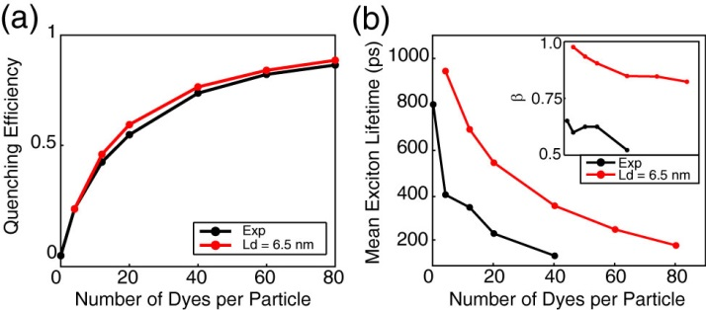

**Fig S2.** Exciton diffusion simulation results ignoring quenching by defects and Poisson statistics. (a) Simulated (red) and experimental (black) quenching efficiency, (b) mean exciton lifetimes, and *ß* (inset) as a function of dyes per nanoparticle for a particle radius of 12 nm.

The Stern-Volmer analysis yields a quenching radius of 5.3 nm for perylene red--significantly higher than the Förster radius *R0*, even if we make favorable assumptions regarding orientation, clearly indicating that exciton diffusion contributes significantly to the quenching efficiency of the dye. However, analysis of the quenching efficiencies alone does not clearly indicate the relative contributions of *LD* and *R0*: Results of exciton diffusion simulations (c.f. Fig S3) indicate that an increase in *either* *LD* or *R0* (or both) results in an increase in quenching efficiency. While there is no simple, exact analytical formula relating *LD* and *R0* to the *β* parameter, we found that *β* increases monotonically with increasing *LD*, (i.e., increasing *LD* results in a decrease in the amount of heterogeneity in energy transfer rates) while *β* decreases as *R0* increases. By including analysis of the *β* parameter, as well as quenching by defects, we obtained a significantly larger value for the Förster radius than that obtained using the typical assumption of *κ2* = 2/3, suggesting that this assumption may not be accurate for this system.{Wu, 2008 #1297} These results strongly suggest that a combined approach of measuring exciton decay kinetics, quenching efficiency, and modeling (in which quenching by defects is explicitly included) is necessary in order to disentangle the combined effects of exciton diffusion and energy transfer on exciton quenching efficiencies and dynamics.

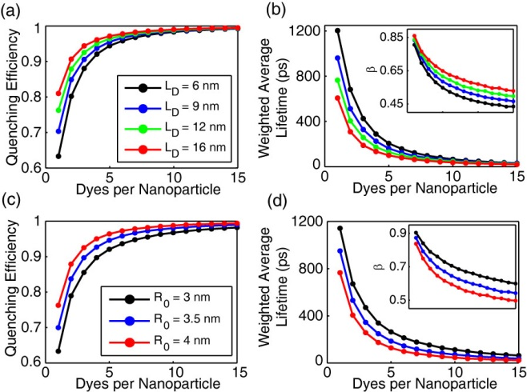

**Fig. S3.** Initial exciton diffusion simulations for a 4 nm particle radius. (a,b) Quenching efficiency, bi-exponential weighted average lifetime, and *ß* (inset) vs. dyes per nanoparticle for LD = 6 nm (black), 9 nm (blue), 12 nm (green), and 16 nm (red). (c,d) Quenching efficiency and bi-exponential weighted average lifetime, and *ß* (inset) vs. dyes per nanoparticle for R0 = 3 nm (black), 3.5 nm (blue), and 4 nm (red).

Another important issue is the effect of quenching by defects on the determined exciton diffusion parameters, particularly the diffusion length and calculated *R0*. By explicitly including quenching by defects in the simulation and analysis, we obtain an (intrinsic) exciton diffusion length (i.e., an exciton diffusion length for a hypothetical defect-free material). The intrinsic exciton diffusion length is 85% larger than the phenomenological diffusion length obtained from dye-quenching analysis without inclusion of defect quenching. This result has several implications. First, that for cases where conjugated polymers exhibit a large decrease in fluorescence quantum yield in the aggregated state (i.e., films and particles) relative to the polymer dissolved in a good solvent, this may indicate highly mobile excitons undergoing energy transfer to a small fraction of defects. Thus, somewhat paradoxically, a large value of *D* can result in a small observed value for the diffusion length, *which in many such cases is determined largely by the density of quenching defects rather than by the diffusion constant*. Second, the approach and results presented here suggest a general method for determining both the defect density and the effect of quenching by defects on the measured exciton diffusion length. Third, the low defect densities we obtained (much lower than 1 defect per polymer chain) and large exciton diffusion lengths determined in the absence of quenching lend qualitative support to the extraordinarily large exciton diffusion lengths reported in the single molecule studies of Barbara et al.{Bolinger, 2011 #1257} Additionally, the significantly larger exciton diffusion length obtained from the lifetime analysis is promising for applications requiring large exciton diffusion lengths, such as photovoltaic devices. Finally, while the nature of quenching defects varies from polymer to polymer, in the case of some PPV derivatives as well as polyfluorene derivatives, quenching defects appear to be partially oxidized polymer, or hole polarons.{Hintschich, 2003 #1269;Tian, 2013 #1293} In the case of hole polarons, quenching by defects can sometimes be suppressed by addition of electron-donor species.{Tian, 2013 #1293;Tian, 2013 #1293;Tian, 2013 #1293;Tian, 2013 #1293} Thus the addition of such species could be helpful for applications requiring larger exciton diffusion lengths.

**3.7 PicosecondModeling Exciton Transport in Blended CPNs**